Lab4

Kevin Wang

Chelsey Yin

In this problem, we want to recognize different shapes from their features, which are elongation and circularity. We choose the first way of calculating circularity. We summary their pattern through some example and try to get a criteria to distinguish them.

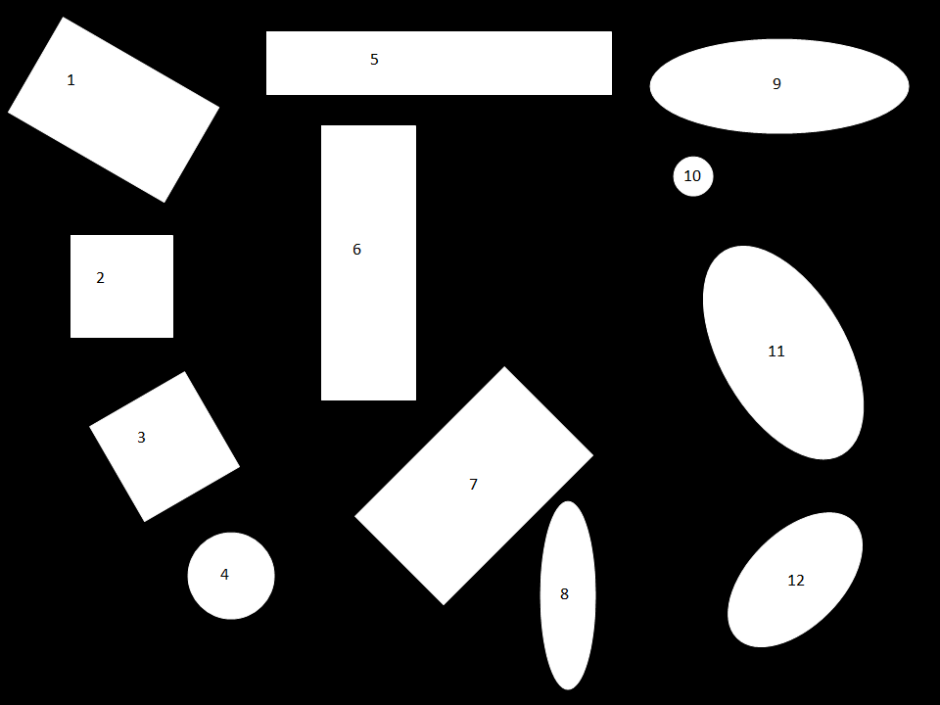

Original picture with number labels

Here is the data we get.

|  |  |  |  |  |  |
| --- | --- | --- | --- | --- | --- |
| Index | perimeter | elongation | circularity (c1) | Shape(true) | Shape(detected) |
| 1 | 638.6072 | 1.6326 | 19.2531 | Rectangle | Rectangle |
| 2 | 416 | 1 | 15.6967 | Square | Square |
| 3 | 482.5412 | 1.0006 | 17.9457 | Square | Square |
| 4 | 295.0782 | 1.0005 | 13.7401 | Circle | Circle |
| 5 | 832 | 5.4314 | 30.1688 | Rectangle | Rectangle |
| 6 | 752 | 2.8970 | 20.7471 | Rectangle | Rectangle |
| 7 | 691.3078 | 1.6739 | 16.8663 | Rectangle | Ellipse |
| 8 | 443.7645 | 3.3498 | 22.2466 | Ellipse | Rectangle |
| 9 | 630.2742 | 2.7170 | 19.4243 | Ellipse | Rectangle |
| 10 | 135.8823 | 1.0065 | 13.3603 | Circle | Circle |
| 11 | 626.9260 | 1.8601 | 15.9305 | Ellipse | Ellipse |
| 12 | 448.4163 | 1.7334 | 15.4023 | Ellipse | Ellipse |

We first differ circle from other shapes. For all the circles, their circularity should be about the same. It is about 13.5 in our data. So we say that all the shapes has a circularity less than 14 is a circle. Then we see the elongation. For all the shapes except circle, square will be the only shape has an elongation for about 1. So we say that all the shapes has an elongation less than 1.1 is a square. Then we need to distinguish rectangles and ellipse. Because ellipse is more “circular” than rectangle, we try to differentiate them according to the circularity. We set the threshold to be 19, which means all the shapes with a circularity larger than 19 is a rectangle. Otherwise is an ellipse. However, we did not get quite accurate here, because some of the ellipses can be quite flat so that has a large circularity.

During the task, we made some small mistakes. For example, we forgot to connect the last pixel with the first one. We forgot to square the elongation and lead to a wrong result. The different between rectangle and ellipse are quite small. So it is hard to differ them.